Homework 5 - Oscar Award Project - Best Actor

2.

1. Oscar Awards Table:

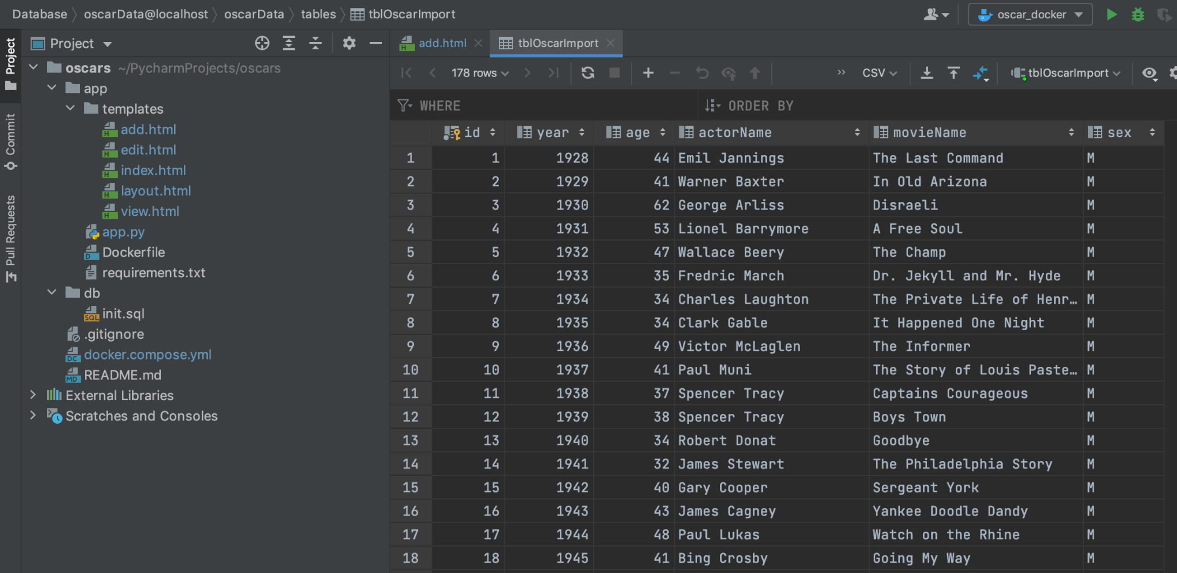

1. Home Page:

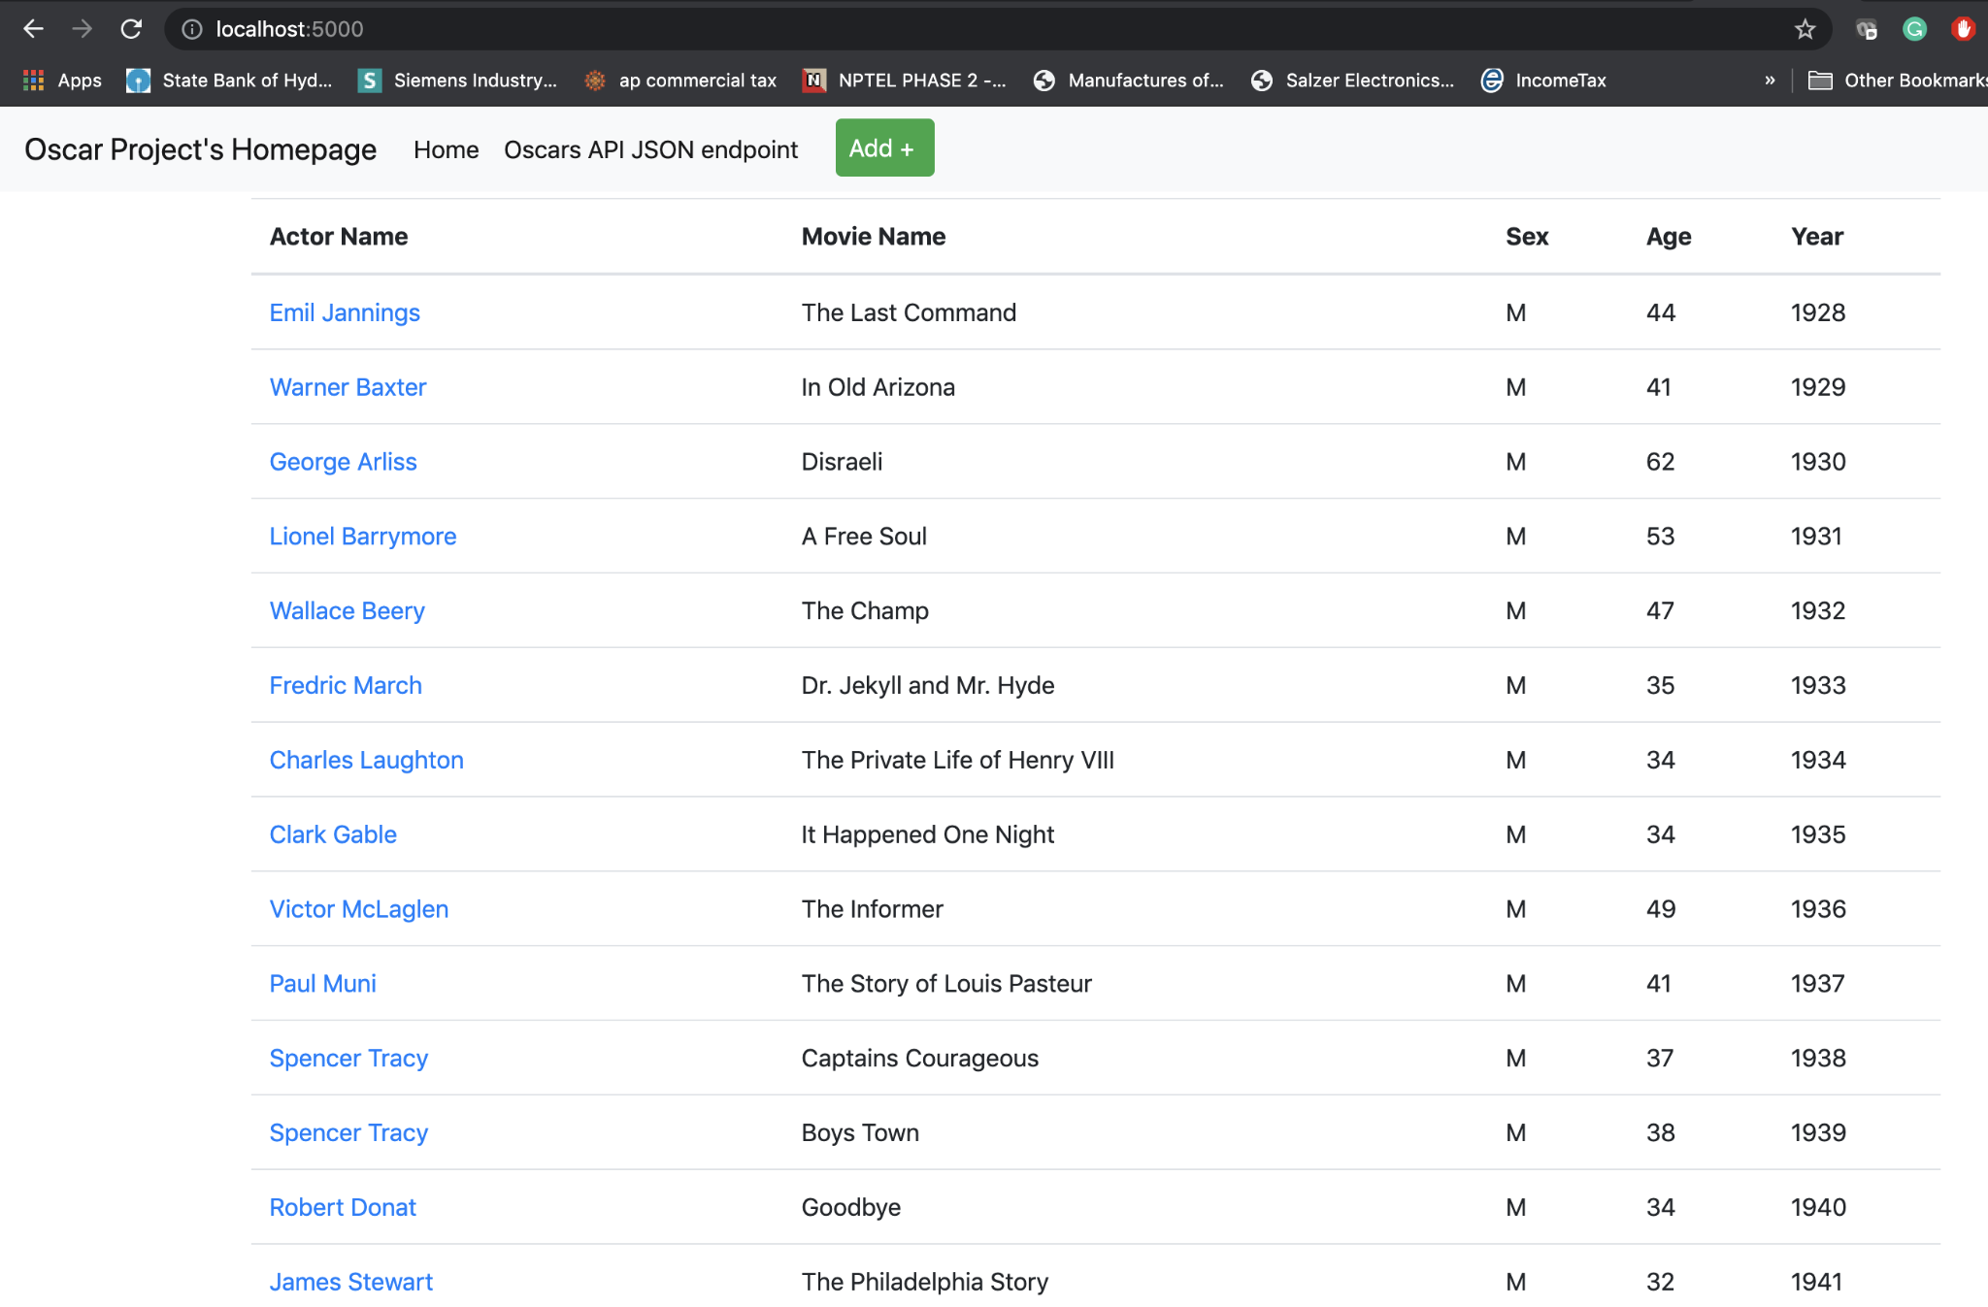

1. View of record:

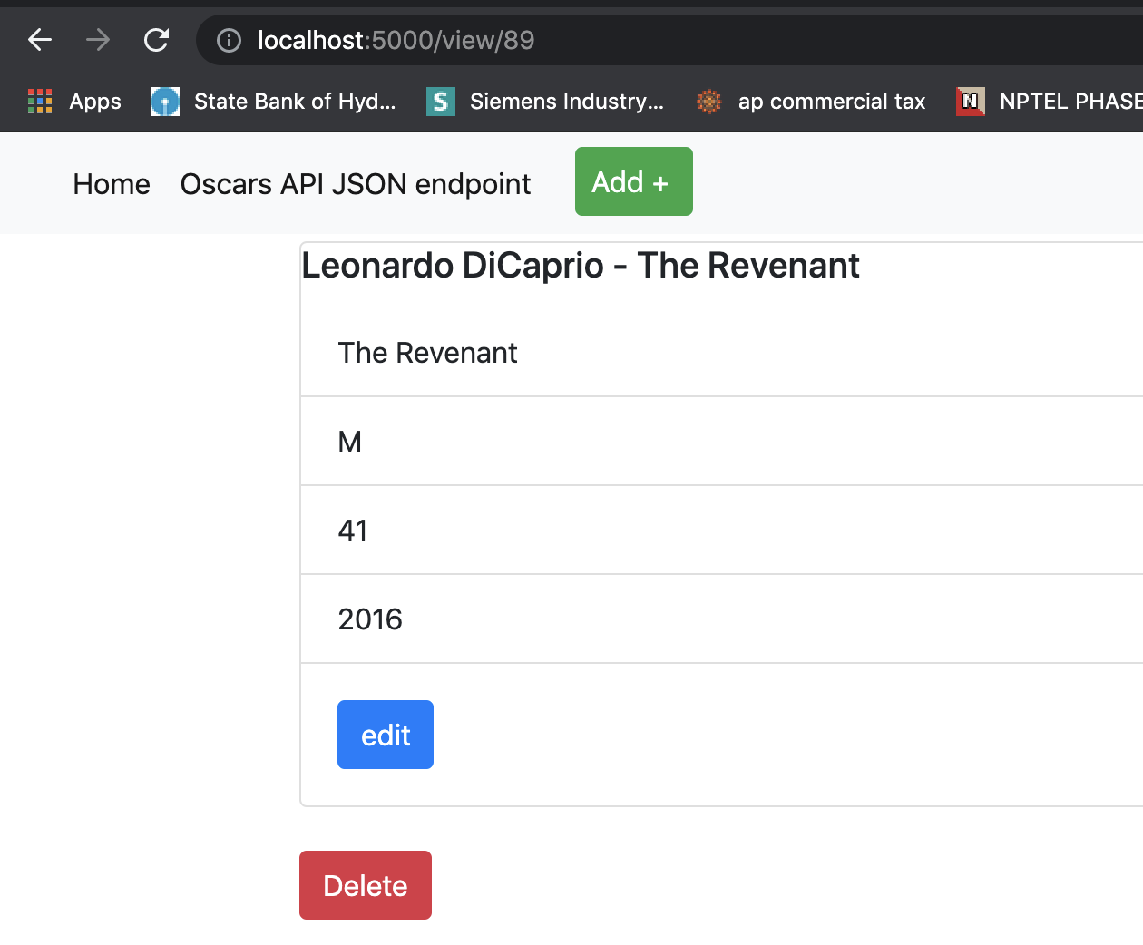

1. Addition of record:

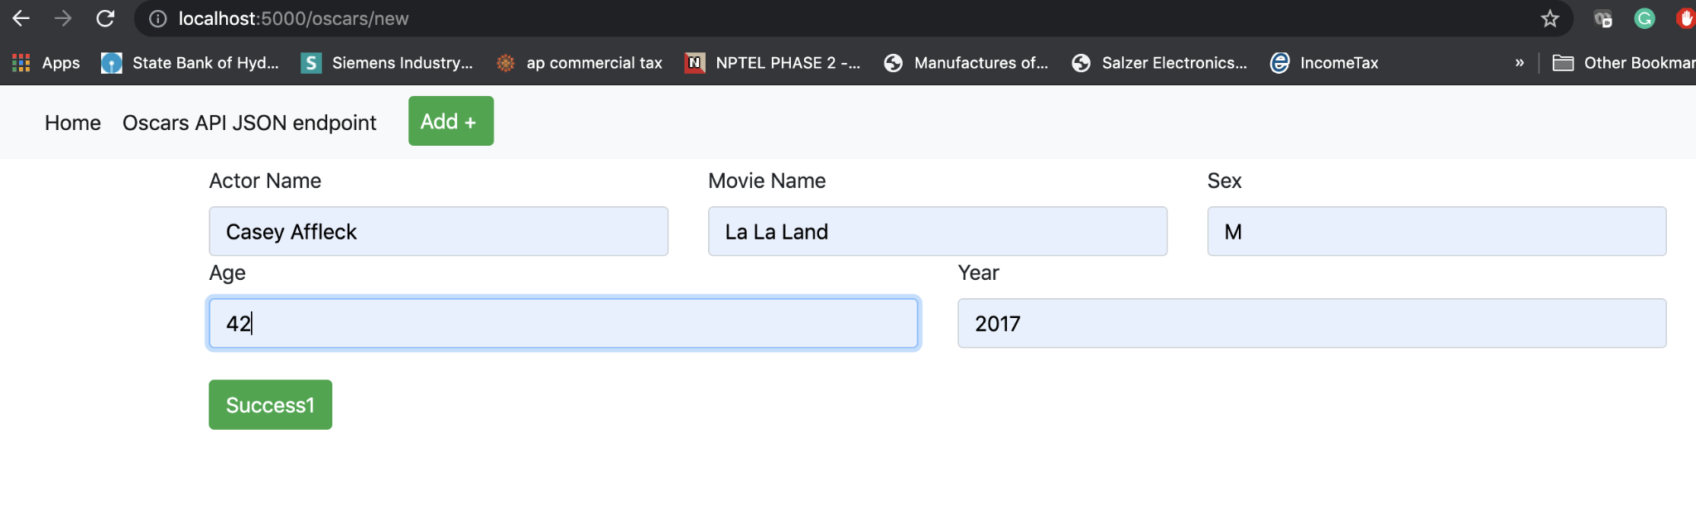

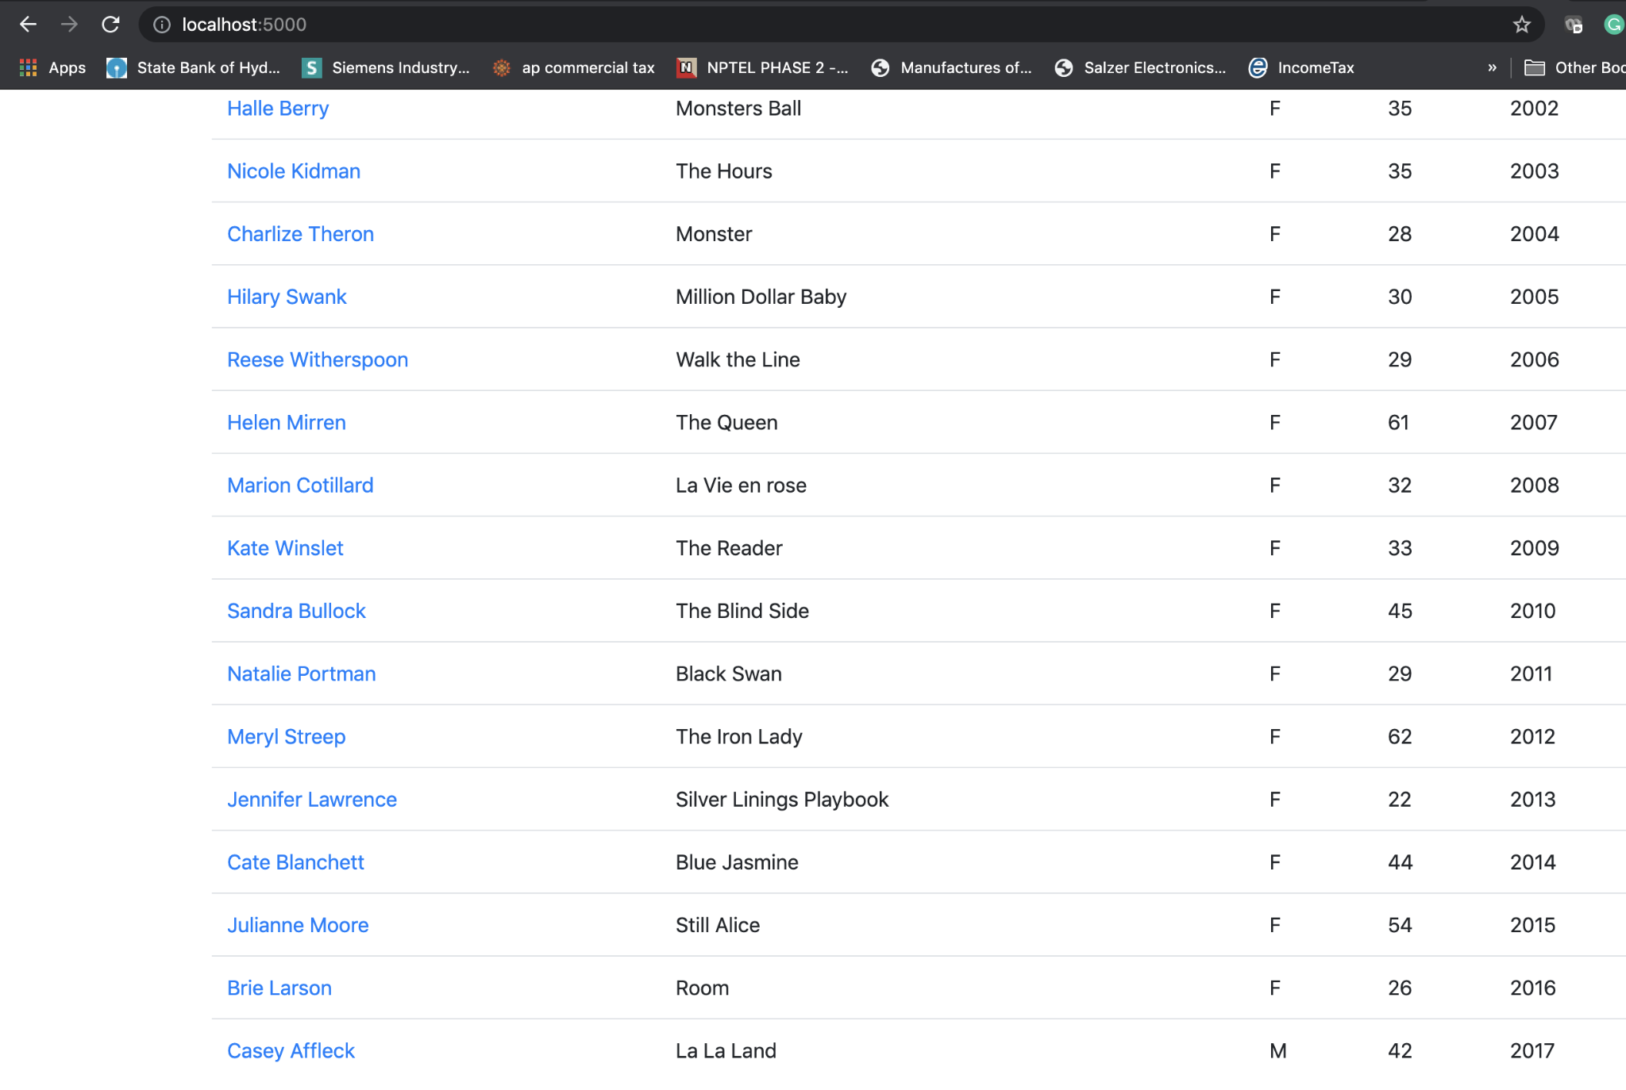

1. Updated record:

Changed Age

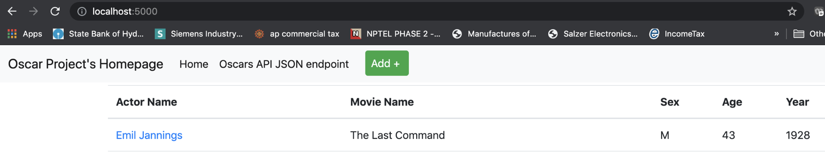

1. Deleted Record

Deleted the record “Emil Jannings - The Last Command”

